**Spring Data JPA with Spring Boot, Hibernate**

**INTODUCTION**

In enterprise Java development, managing database interactions is a crucial part of application architecture. To simplify this task, the Java ecosystem provides a set of tools and frameworks — namely **Java Persistence API (JPA)**, **Hibernate**, and **Spring Data JPA**. These technologies work together in layers, each serving a specific purpose in making data access more consistent, maintainable, and developer-friendly. JPA defines the standard way of persisting Java objects to relational databases, Hibernate provides the actual implementation of this specification, and Spring Data JPA further simplifies the process by reducing boilerplate code through powerful abstractions. Understanding how these three components work individually and together is essential for building modern, data-driven Java applications.

**1. What is Java Persistence API (JPA)?**

JPA stands for Java Persistence API.  
It is a specification (a set of rules/standards) in Java for managing data between Java objects and a relational database (like MySQL, PostgreSQL, etc.).

**Key Points:**

* It is not an implementation, just an interface or contract.
* It helps you map Java classes to database tables.
* Provides annotations like @Entity, @Table, @Id, etc.
* Requires an implementation (like Hibernate or Eclipse Link).

**Example:**

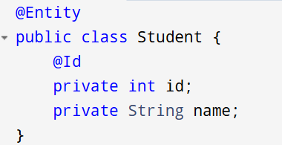

**Analogy:** JPA is like a blueprint for how to interact with databases. It defines what to do, not how to do it.

**2. What is Hibernate?**

Hibernate is a popular ORM (Object-Relational Mapping) framework in Java that provides the actual implementation of JPA.

**Key Points:**

* Implements JPA and adds extra features (like HQL, caching).
* Helps convert Java objects into database rows (and vice versa).
* Manages database operations: save, update, delete, fetch.

**Example:**

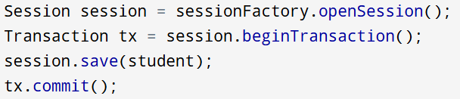

**Analogy:** If JPA is the recipe, Hibernate is the cook that follows the recipe and prepares the dish (interacts with the database).

**3. What is Spring Data JPA?**

Spring Data JPA is a part of the Spring Framework. It builds on top of JPA and provides automatic implementations of repositories, reducing boilerplate code.

**Key Points:**

* Not a JPA implementation (uses Hibernate internally).
* Helps you create DAO (Data Access Object) layers with no implementation code.
* Uses interfaces like JPA Repository.

**Example:**

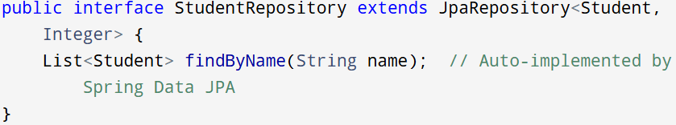

**Analogy:** Spring Data JPA is like a kitchen assistant who automatically prepares ingredients (methods) based on the recipe (JPA) and tools (Hibernate).

**Difference between JPA, Hibernate and Spring Data JPA**

|  |  |  |  |
| --- | --- | --- | --- |
| **Aspect** | **JPA** | **Hibernate** | **Spring Data JPA** |
| **Type** | JPA is a Java specification (JSR 338) that defines the standard for object-relational mapping (ORM). | Hibernate is a full-fledged ORM framework that also serves as a JPA implementation. | Spring Data JPA is a part of the Spring Framework that provides an abstraction layer over JPA. |
| **Purpose** | JPA standardizes the way Java objects are mapped to relational databases using annotations and APIs. | Hibernate offers the actual implementation of JPA and adds additional ORM features. | Spring Data JPA simplifies the use of JPA by minimizing the amount of boilerplate code developers must write. |
| **Implementation Provided** | JPA does not provide any implementation; it needs a provider such as Hibernate or Eclipse Link. | Hibernate provides a working implementation of JPA and adds its own features and optimizations. | Spring Data JPA does not provide an implementation of JPA; it depends on a JPA provider like Hibernate. |
| **Boilerplate Code** | JPA requires developers to write the full persistence logic using Entity Manager and custom DAOs. | Hibernate reduces the boilerplate compared to JDBC but still requires manual coding of sessions. | Spring Data JPA removes much of the boilerplate by automatically generating repository implementations. |
| **Query Languages** | JPA supports JPQL (Java Persistence Query Language), which is object-oriented and SQL-like. | Hibernate supports JPQL and adds HQL (Hibernate Query Language), which is more feature-rich. | Spring Data JPA supports JPQL, derived queries based on method names, and custom queries using @Query. |
| **Advanced Features** | JPA is limited to the features defined in the specification. | Hibernate includes additional features like caching, lazy loading, interceptors, and HQL support. | Spring Data JPA does not add ORM features but relies on the underlying JPA provider (e.g., Hibernate). |
| **Ease of Use** | JPA is moderately easy to use but requires manual setup, configuration files and writing DAO logic and transactions. | Hibernate is easier than plain JPA in some aspects but still needs explicit session handling. | Spring Data JPA is the easiest to use among the three, especially with Spring Boot’s auto-configuration. |
| **Integration with Spring** | JPA can be used with Spring, but the integration must be done manually through configuration. | Hibernate can also be integrated with Spring manually or via Spring ORM modules. | Spring Data JPA is designed for seamless integration with Spring Framework and Spring Boot applications. |
| **CRUD Operations** | CRUD operations must be manually written in the DAO layer using Entity Manager. | Developers must manage sessions and transactions to perform CRUD operations. | CRUD operations are automatically provided by extending interfaces like JPA Repository. |
| **Transaction Management** | JPA uses Entity Manager for transaction management and requires manual demarcation or annotations. | Hibernate manages transactions via Session or can use Spring's @Transactional support. | Spring Data JPA handles transactions declaratively using Spring's @Transactional annotation. |
| **Use Case** | JPA is best suited when a vendor-independent, standardized ORM layer is required. | Hibernate is ideal when developers need full ORM control and advanced features beyond JPA. | Spring Data JPA is preferred when rapid development and tight integration with Spring is desired. |

**Code Comparison Between Hibernate, JPA, and Spring Data JPA**

1. **Hibernate**

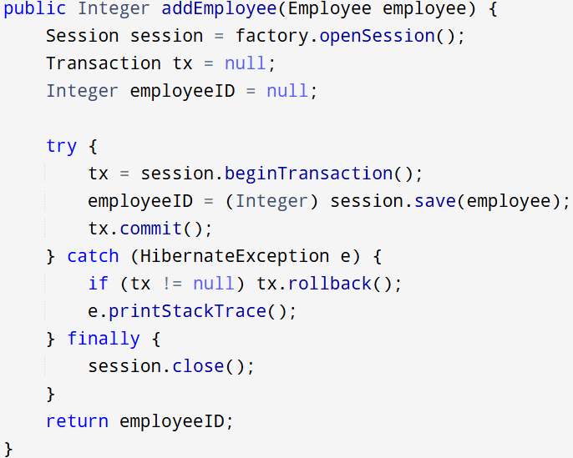

1. **Spring Data JPA**

* ***EmployeeRepository.java***

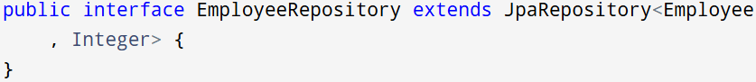

* ***EmployeeService.java***

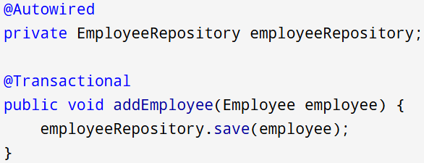

1. **JPA**

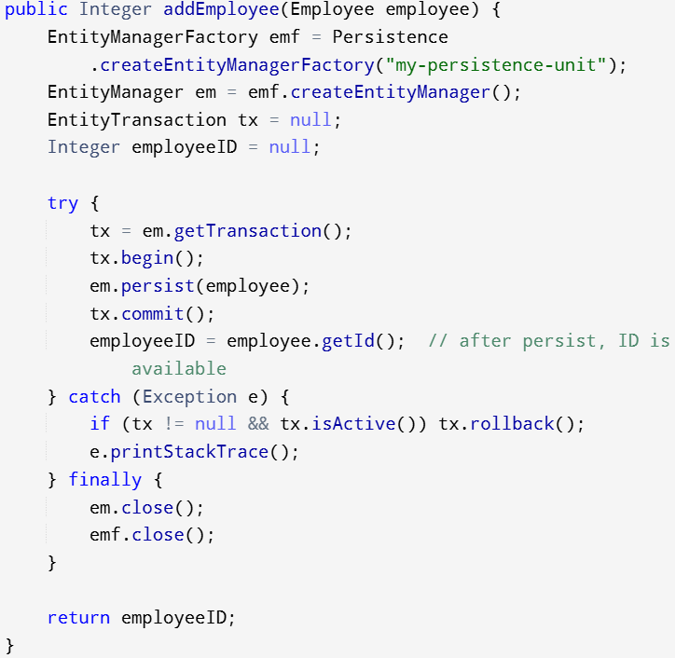

**CONCLUSION**

All three approaches—Hibernate, Plain JPA, and Spring Data JPA—enable Java applications to persist data to relational databases. However, they differ in abstraction level, verbosity, and ease of use:

* Plain JPA follows the official specification and provides a standard way to handle persistence but requires more boilerplate code and manual transaction management.
* Hibernate, as a JPA implementation, adds powerful ORM features like caching and HQL, simplifying some aspects of persistence while still requiring explicit session handling.
* Spring Data JPA abstracts away much of the complexity by leveraging Spring’s dependency injection and auto-configuration, allowing developers to write minimal code for common CRUD operations.

In short, Hibernate is ideal for full control, JPA for standards compliance, and Spring Data JPA for rapid development within Spring-based applications.